CaseManagement_CreationOfCase_Instance23_03-Aug-2018_08-06-45_AM_MouseClickActionMoveToElementByxpathimgaltServiceparentspan.png

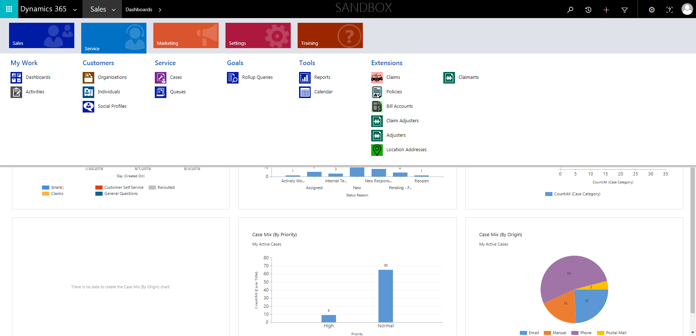

CaseManagement_CreationOfCase_Instance23_03-Aug-2018_08-06-06_AM_EnterTextAction.png

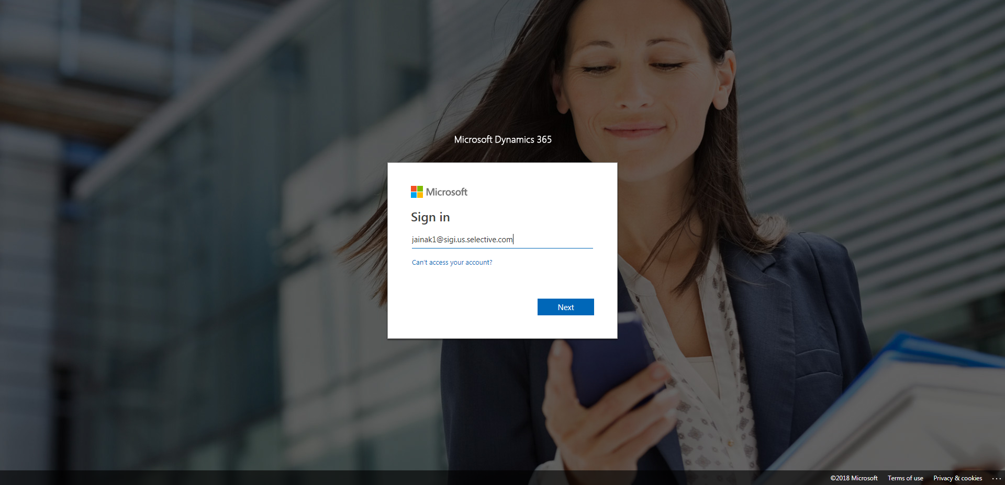

CaseManagement_CreationOfCase_Instance23_03-Aug-2018_08-06-43_AM_MouseClickActionMoveToElementBycssSelectorspanTabSFA.png

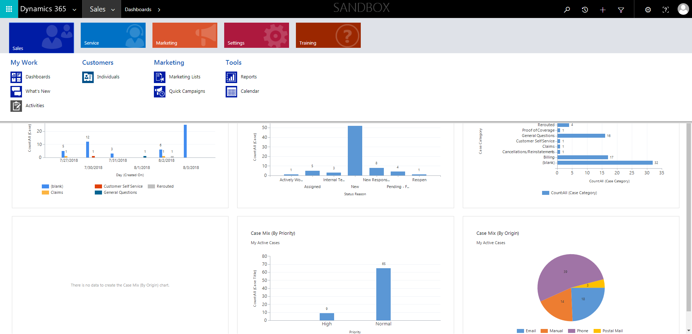

CaseManagement_CreationOfCase_Instance23_03-Aug-2018_08-06-46_AM_MouseClickActionMoveToElementBycssSelectoranavcases.png

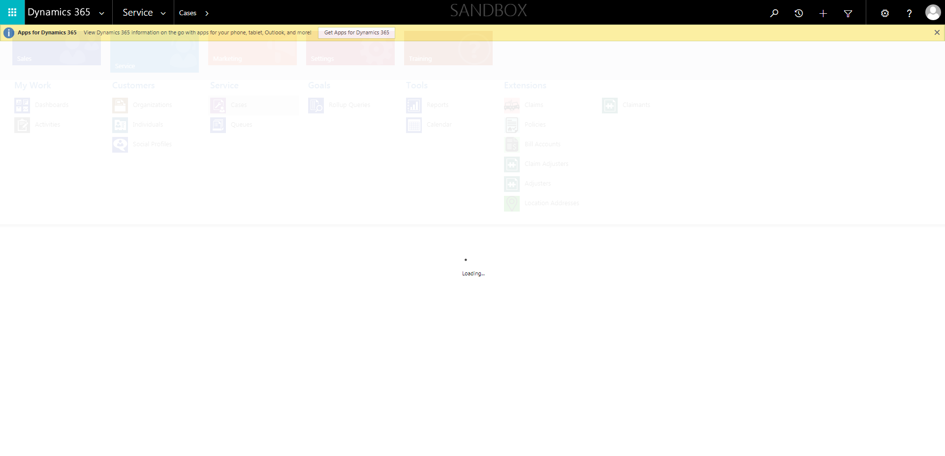

CaseManagement_CreationOfCase_Instance23_03-Aug-2018_08-06-37_AM_SingleSignOn.png

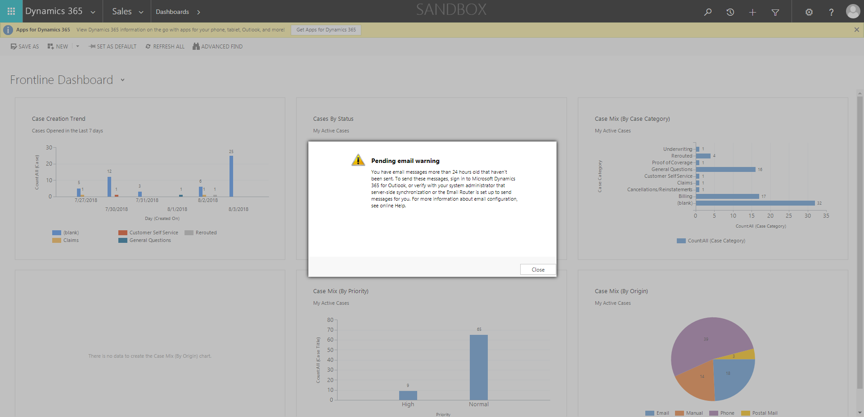

CaseManagement_CreationOfCase_Instance23_03-Aug-2018_08-06-07_AM_MouseClickActiononStaleElement.png

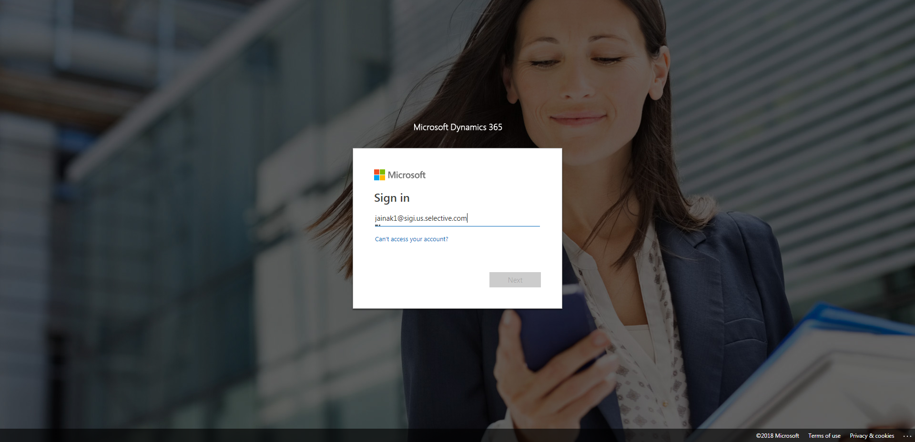

CaseManagement_CreationOfCase_Instance23_03-Aug-2018_08-06-40_AM_SingleSignOn.png

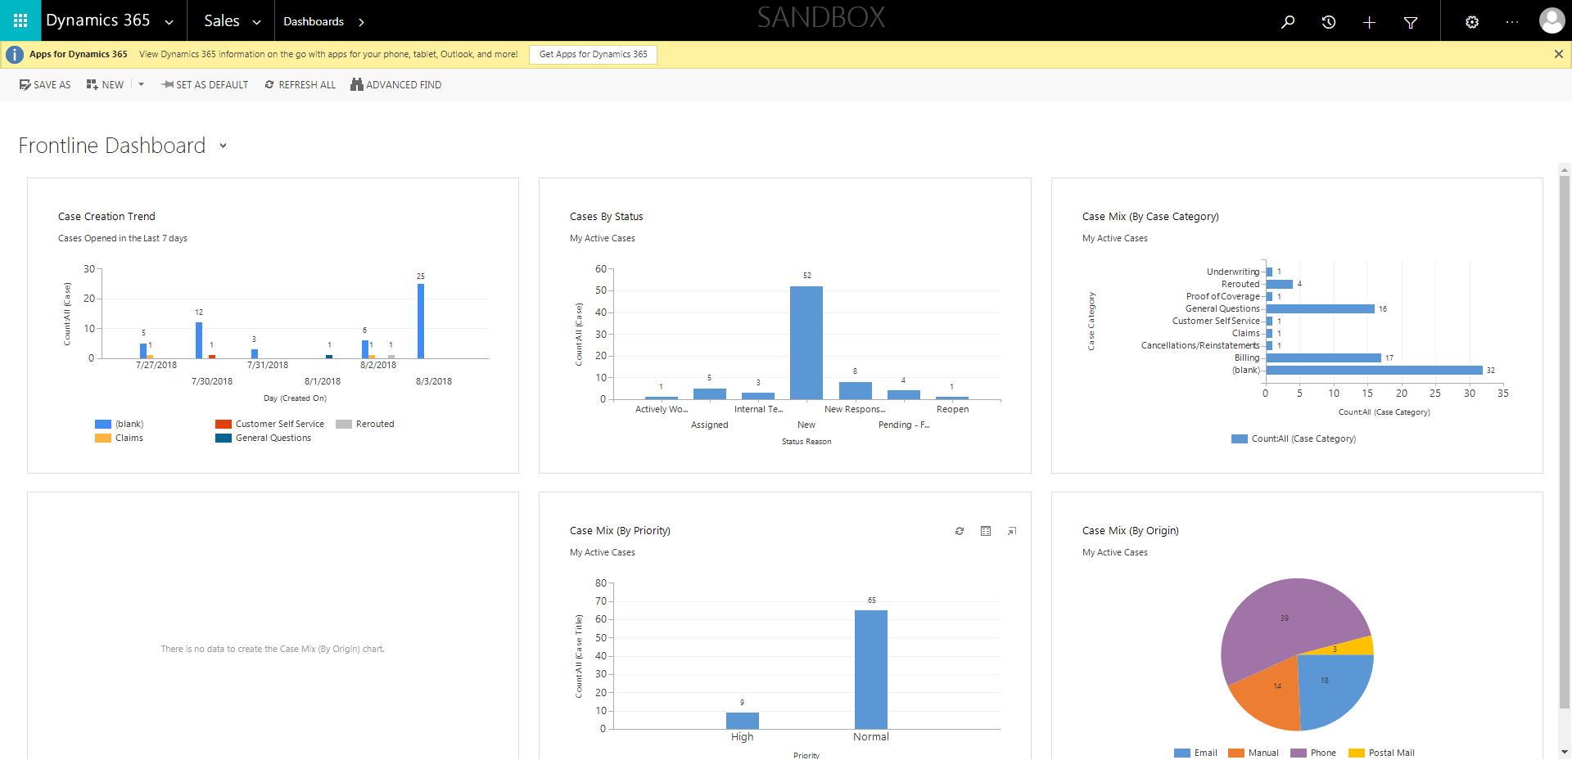

CaseManagement_CreationOfCase_Instance23_03-Aug-2018_08-06-04_AM_MouseClickActiononStaleElement.png

